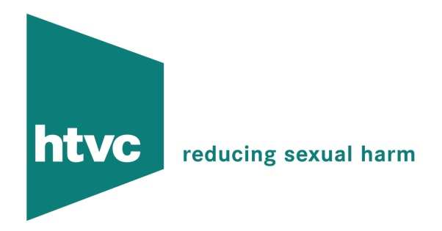

ASSESSMENTS TRAINING AND CONSULTANCY

Professionals, particularly those new to working with sexual offenders, can find it stressful and potentially de-skilling. HTV Circles staff and consultants can provide training in the following areas:

- Working with Sexual Abuse – increasing knowledge of typologies of offender, the legal framework in which we operate, fears and methods of managing these, what do we already know that we can use in the specialist field?
- Risk assessment of the likelihood of re-offending – understanding other professionals’ assessments, and contributing effectively to these – signs that risk may be increasing
- Sex offender treatment – understanding the process of treatment and being in a better position to complement treatment aims.
- Working as a team – personal and team boundaries, team structures for a supportive and effective environment
- Advanced Training – listening skills, working with manipulation, increasing teams’ skill base.

We also offer consultancy for teams, consisting of regular forums in which to discuss cases, professional issues, together with more formal training input.

HTV Circles have a number of colleagues available to undertake risk assessment reports for sexual offenders. These can provide a guide as to the likelihood of reoffending within a given context. These can include assessments of risk within families, and partners/carers’ ability to protect children.

For more information please contact us on info@htvcircles.org.uk

