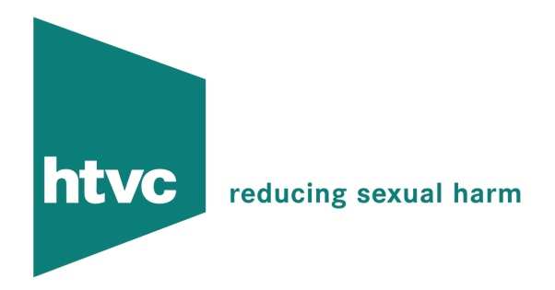

A TYPICAL TWO-DAY TRAINING AGENDA

Day One

10.00 Arrival, coffee and introductions

10.15 Attitudes and Beliefs Exercise

11.15 Coffee

11.30 Working with Sexual Offenders:-

- Working with denial
- Examples of treatment methods
- Balancing support and accountability

1.00 Lunch

2.00 Risk Assessment of sexual offending

3.15 Coffee

3.30 Personal boundaries and wellbeing

- Issues from participants
- Professional coping strategies
- Maintaining boundaries
- Personal and professional support networks
- Appropriate use of supervision

4.15 Discussion about any issues raised during the day

4.30 Close

Day Two

  - Arrival and coffee

10.00 Personal boundaries and self-care (continued from previous session)

  - Break

  - Guarding against manipulation

  - Lunch

  - Listening skills

  - Break

  - Relapse Prevention/Better Lives (Good Lives theory)

4.00 Close

