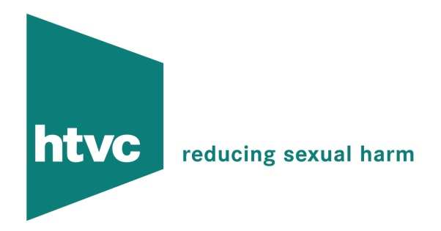



CONTACT US

Head Office Address:

PO Box 240
Didcot
Oxon
OX1 1AT Telephone number 01235 816050

E-mail:

For information about Circles, training, our Non-Abusing Partner Programme (“Breaking the Cycle”), consultancy, assessment reports. our mentoring scheme or volunteering with us, e-mail info@htvcircles.org.uk

