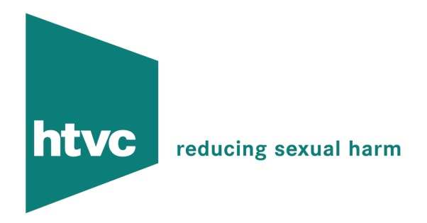


Prizewinner of the Lord Longford Award 2004
Special Merit Award, Howard League Community Programme Award 2006Winner for Outstanding Contribution to Engaging Communities, The Justice Awards 2006
Winner Thames Valley Justice Awards 2006
Winner Queen’s Award for Voluntary Service 2010

Circles South East and HTVC are part of HTV Circles, an independent charitable company. One of two government pilot projects formed in 2002, we have been contributing to the safe and effective management of convicted sexual offenders who have made a commitment to cease offending, but who potentially pose a high risk of reoffending in the community. We are one of a number of projects providing Circles of Support and Accountability, under the auspices of Circles UK, a separate charity responsible for the development and coordination of projects, and the maintaining of standards of practice. Please follow the link to find out more about Circles UK and other projects delivering Circles.

We work in partnership with the Police, Probation and Prison services, within the framework of the Multi Agency Public Protection Arrangements (MAPPA). We are funded by Probation and Police, by various charitable trusts, and through income generating work undertaken under our sister company HTVC

Although traditionally our core work has been to offer Circles of Support and Accountability, we are expanding our range of services to include:

- A programme for non-offending partners of sexual abuse
- Training and consultancy for teams new to working with sexual offenders
- A 1-1 mentoring service for sexual offenders
- A counselling service for offenders
- A counselling service for the survivors of sexual abuse
- Risk assessments on offenders

Please view other areas of the site for further information on these services, or if you would like to know more about volunteering with us. We also offer volunteering opportunities in our mentoring scheme, and work with non-offending partners.

Circles of Support and Accountability

A Circle is essentially a small group of volunteers (between three and five) who meet regularly with a sexual offender (or Core Member) in order to provide a supportive environment in which the Core Member can discuss their offending behaviour, and ways of avoiding re-offending. The group can help the offender in various practical ways, such as with housing, employment, budgeting etc, but importantly also helping them to develop social skills and trust in adult relationships.

Volunteers are trained, vetted and supervised throughout this process. We also have additional training for volunteers who wish to develop particular skills, such as housing, risk assessment, listening skills, group dynamics etc.

We are currently moving towards our hundredth Circle, as well as offering counselling and mentoring to numerous other offenders. We also have experience in organising Circles specialising in :

- Faith communities
- Offenders with a learning disability
- Offenders with personality disorders
- Female offenders

Of all the offenders who have been in our Circles, only 1 has been reconvicted of a further sexual offence, demonstrating the effectiveness of our methods.

There are various pages on this site which give you more information about the work that we do. Also, you can contact us at info@htvcircles.org.uk.

